Friendship
cheers
awards
belt loops
patches
skits
citizenship
Camping
Hiking
fishing
Swimming
boating
campfires
nature climbing
sports
field sports
Friendship
cheers
awards
belt loops
patches
skits
citizenship
Camping
Hiking
fishing
Swimming
boating
campfires
nature climbing
sports
field sports
camping hiking sports cooking field sports knot tying pinewood derby races community service fieldtrips friendship nature trails
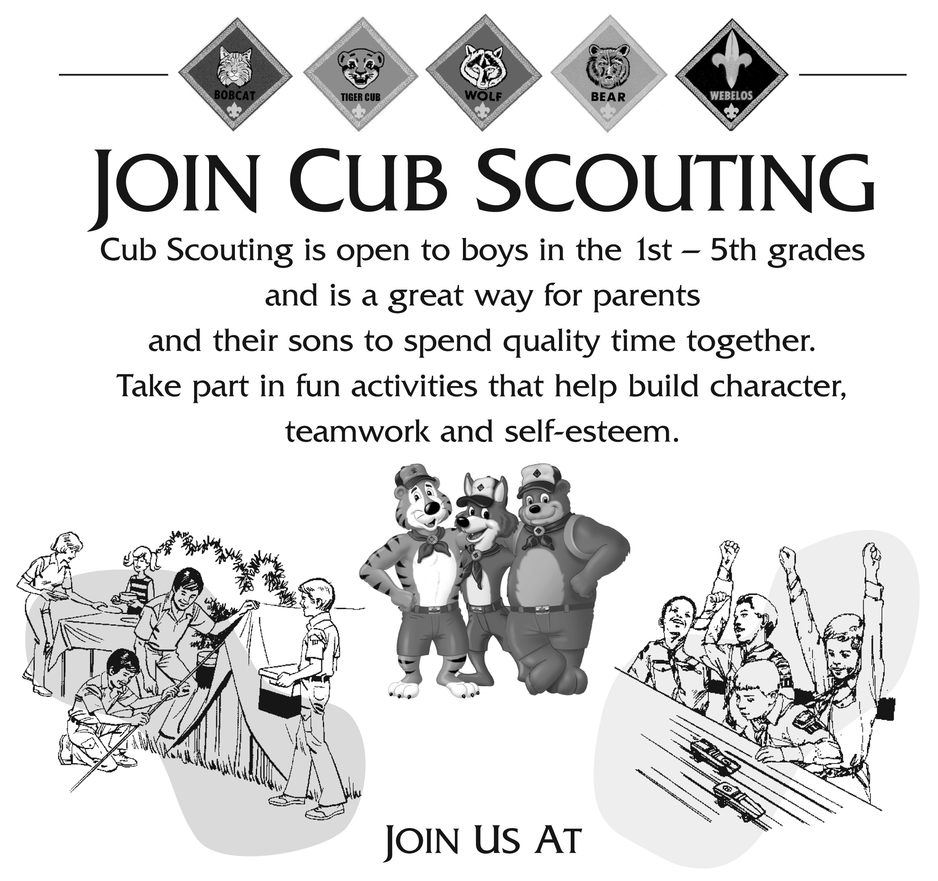

Join us at…

Riverside Community Center
Friday, October 24 at 7PM

For more information contact:
Heather Kenney at 410-272-1769

hldkenney@yahoo.com

There is also a Boy Scout Troop in your area for boys ages 11-18
Contact Paul Dennis at 410-273-1052
camping hiking sports cooking field sports knot tying pinewood derby races community service fieldtrips friendship nature trails

